Airline Safety Dashboard

The main things I decided to focus on was the overall trends for overall air travel and then accident frequency and the severity of those incidents (did they result in fatalities or not?). I also wanted to see if there were any notable differences between the airline companies and destinations. Finally, how do the number of fatalities compare to another popular form of travel – driving?

***Color scheme:***

General color scheme follows the idea that fatality is red (or shades of pink to indicate intensity) for the most dangerous. Accidents are a light teal color while general information is a neutral dark blue. I mostly tried to focus on gradients rather than different colors within the same graph, except for the Type of Airline Accident graph where both red and teal occur together. I did try to make sure the shades were different enough that even in grayscale, you could still distinguish between the two.

***Graph choice:***

Most of the data is displayed over time so bar charts and line graphs are appropriate. I decided to fill in the line graphs (like cumulative graphs) to facilitate ease of comprehension as the shape is easier to see than a thin line and the mass of color shows the trends well. Bar graphs were used when two separate values were displayed for each year to enable the pairing. Particularly in the Type of Airline Accident, an overlapped bar chart was necessary as the red fatal accidents are a part of the total blue bar.

The last figure type is a pair of packed bubble charts. These were chosen to illustrate numerical comparisons between quite a few categories (airline operators or routes). The actually values here aren’t quite as important as identifying the “worst” couple categories in each matchup.

***Data Sources:***

* Accidents numbers from Accidents and Fatalities Per Year (<https://docs.google.com/spreadsheets/d/1SDp7p1y6m7N5xD5_fpOkYOrJvd68V7iy6etXy2cetb8/edit#gid=1448957446>).
* Airplane Crashes 1908-2009 (<https://data.world/hhaveliw/airplane-crashes-1908-2009>)
* NHTSA Summary of Motor Vehicle Traffic Crashes (<https://www-fars.nhtsa.dot.gov/Main/index.aspx>)
* Safety Record of U.S. Air Carriers (<https://www.airlines.org/dataset/safety-record-of-u-s-air-carriers/>)

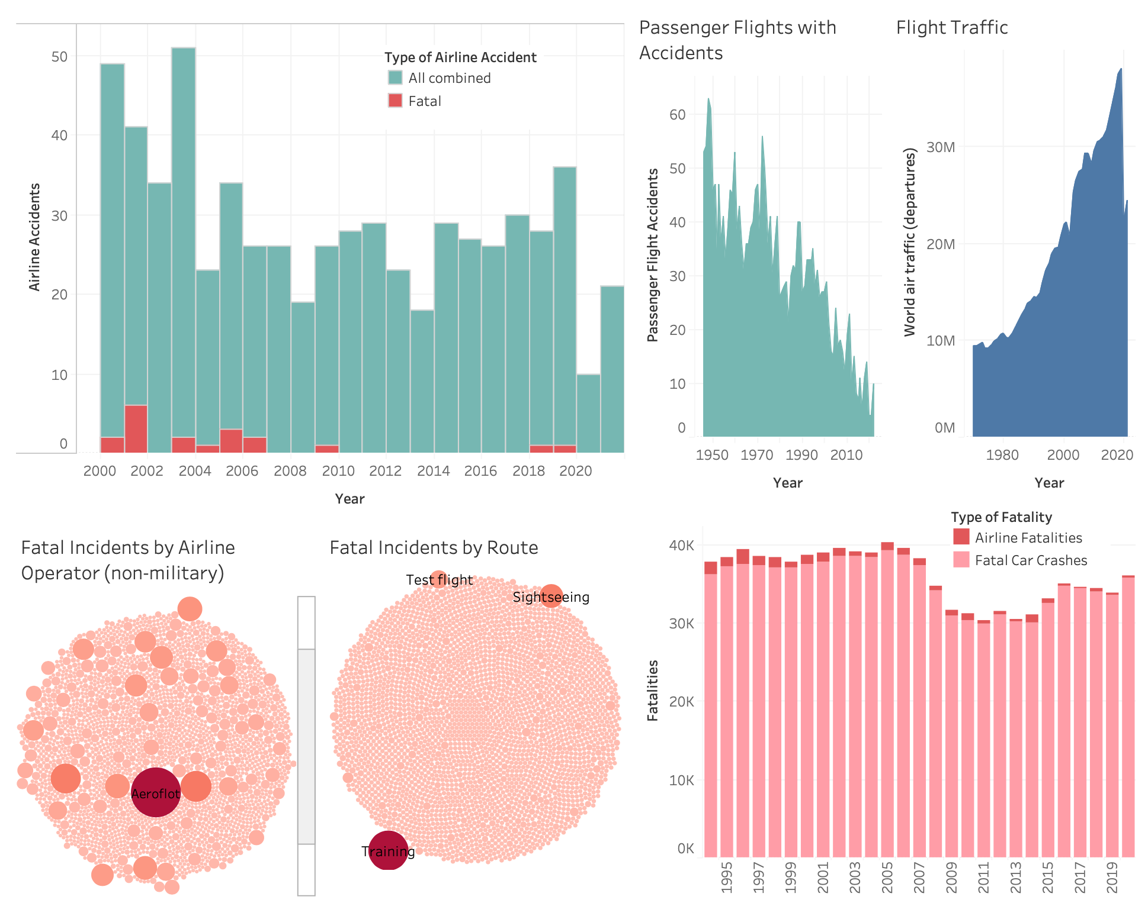

***Main Takeaways:***

* The number of flights has almost quadrupled since the 1970s. (Flight Traffic)
* Meanwhile the number of accidents, which was already low to begin with, has also steadily dropped to almost 1/6th the number in the 1950s. (Passenger Flights with Accidents)
* When we look at the break down of accidents, we see that a very small percentage (less than 1/5) of the accidents wind up being fatal and that percentage is getting smaller and smaller. (Type of Airline Accident)
* When we break down the fatalities by operator we see that you might want to avoid Russian airline Aeroflot due to their disproportionately high fatalities (179 incidents alone), but other than that we typically see larger airline operators with the larger counts which makes sense due to their higher volume. (Fatal Incidents by Airline Operator)
* By route, most flights show that fatal incidents occurred during training, test, or sight sighting excursions. Almost all other routes have less than 2 incidents each. (Fatal Incidents by Route)
* Finally, if we compare the number of fatalities from airplanes to the number of fatal car crashes just here in the US, we see the number is vastly dwarfed by the massive amounts of people killed each year by being on the road. In some cases the airline fatalities are barely even visible on the graph. Note how the slivers for the airline fatalities get thinner as time goes on echoing the decreases seen in other graphs. (Type of Fatality)

***Ethics and Improvements:***

The biggest issue that I see is that with the data coming from multiple sources, there are some inconsistencies that would need more scrutiny. For example, the Type of Airline Accident graph contains data from the Safety Record of U.S. Air Carriers but it doesn’t seem to match the Passenger flights with Accidents numbers from Accidents and Fatalities Per Year. Overall the accuracy of any of these datasets has not been researched.

Ideally there would also be a bit more standardization in many of the figures. For example, I would love to redo the packed bubble charts with numbers that take into account the frequency of each route or the number of flights each airline ran during the time the incidents were collected. This would give a better comparison between more popular routes or airlines compared to those less traveled.

I would also love to add a few other types of transportation (maybe passenger train, ferries, bike). Right now I am only comparing airplanes and passenger cars).